Ant Group's ABS problem

---A case analysis based on the suspension of listing

Abstract: The suspension of listing by Ant Group puts the risk of the Internet finance industry under the public eye. This case tries to see the big from the small and analyzes the ABS problem of Ant Group, and then finds the risk factors that trigger the enterprise and even the industry environment. Establishing the Copula-GARCH model to calculate the CVaR value of the rate of return, the result is higher than the industry average, it can be determined that the Ant Group does have a risk problem. After that, it analyzes the ABS risk of Ant Group from two different perspectives of basic asset holders and securities investors, and draws conclusions that should pay attention to corporate credit risk issues, and finally put forward three suggestions.
Keywords: Ant Group; ABS; Copula-GARCH; CVaR

1 Introduction
On July 20, 2020, Ant Financial officially announced the change of its name to Ant Technology Group Co., Ltd., and launched a plan to simultaneously issue and list on the SSE Science and Technology Innovation Board and the Hong Kong Stock Exchange. From the submission of the listing prospectus on August 25 to the approval of the sci-tech innovation board registration system on September 18, it took less than 25 days for Ant Group to pass the meeting. After a number of well-known international rating agencies evaluated the market value of Ant Group, the valuation of Ant Group continued to exceed market expectations and eventually reached more than US$300 billion, surpassing Kweichow Moutai in A-shares to become the largest company in expected market value. However, the good times did not last long. On the eve of Ant's upcoming listing, Jack Ma, the main actual controller of the group, and others received an invitation for an interview jointly initiated by the central bank, the China Securities Regulatory Commission, the China Banking Regulatory Commission and the Administration of Foreign Exchange. The specific content of the conversation is unknown, but this incident is followed by the announcement of the suspension of Ant’s listing issued by the Shanghai Stock Exchange. The reason is that the company’s financial regulatory environment (will) has undergone major changes, so that the current company does not have Issuance and listing conditions may not meet the information disclosure requirements. Therefore, Ant Group's initial listing plan can only end in failure, and it is still unknown when the plan can be restarted.
The reason why Ant Group failed to go public was that the official announcement was due to major changes in the regulatory environment of the industry, which temporarily did not meet the new listing conditions and information disclosure requirements. The sudden change in the regulatory environment has led to the failure of companies to go public. This incident illustrates two possibilities. One is that my country has a long-term insufficient understanding of this industry and has not yet been able to find an appropriate way to supervise new types of companies such as Ant Group; Second, through observations on market reactions and the results of investigations on business operations, the industry in which the business is located has significant risks, so reforms are needed to make up for the lack of supervision. Regardless of the possibility, the reasons for the regulatory changes are inseparable from the target's risk level. The following case will start from the risk problem of Ant Group, analyze the main content (namely ABS problem) in more detail, and briefly discuss the methods and countermeasures to solve the problem.

2 Case design and theory

2.1 Case study design
Enterprise risk can be divided into two types: external risk and internal risk. External risks mainly include policy risks, market risks, industry risks, etc.; internal risks mainly include strategic risks, operational risks, and business risks. In this case, it can be found that Ant Group can quickly pass the initial audit, which has explained that there are no major problems in the company's own organizational structure, financial structure, and internal control, and there are few financial crises in the long-term development history of the company. , Staff fraud, managers use power for personal gain. The Ant Group triggered the changes in the regulatory environment this time, and the source of its risk factors is obviously not internal to the company, but determined by the external environment, so this case mainly focuses on external risks.
To analyze the external risks of Ant Group, we must first distinguish the nature of its industry. According to the revenue structure report published by Ant Group many times, its main business can be divided into three categories: payment, technical services and financial services, of which payment and technical services each account for about 45%. The payment business includes payment and settlement, consumer credit and financial debt business carried out by Alipay, Huabei, and online merchant banks, which directly cover all components of the consumer finance field; technical service business includes the use of authorized Alibaba Cloud technology for financial-related Technology output, and technical services related to funds, insurance, and securities. The two main businesses are financial-intensive, so they should be classified as financial enterprises. Financial enterprise is different from entity enterprise, its characteristic is that the importance and proportion of credit risk are greatly increased when discussing industry risk in external risks. Due to the obvious differences between the two main business segments of the Ant Group, they are discussed separately.
The first is payment business. Ant Huabei and Boraibei are the representatives. The business model is essentially similar to consumer credit cards and small and micro loans. As a lender, Ant Group has basically only two sources of funds, namely its own capital and the asset securitization issued in cooperation with Debon Securities (ABS). Therefore, from the perspective of risk, it can be said that the ABS business model of Ant Group reflects most of the risk issues of the payment business, and it has both credit factors and market factors. The second technical service business is relatively more inclined to the nature of the service industry, just like the consulting and agency business in commercial banks, it does not occupy a major position in risk. The main risk in this regard is policy risk. Due to the wide scope of business and a mixed operation, it is easy to face losses due to policy changes. A typical example is the change in Yu'E Bao's provision policy, which is mainly financial services. In summary, the most significant risk of Ant Group is mainly reflected in the payment business, and the payment business is mainly based on the ABS model. Therefore, this case studies the risk of Ant Group to the ABS risk.
The measurement of ABS risk should be multi-level and multi-angle, because the risk categories involved are comprehensive and significant. The VaR method proposed in 1993 is the current mainstream method to measure market risk. At the same time, VaR can also be used to measure credit risk. On the other hand, because VaR reflects the possible loss of a given confidence value, it ignores the possible extreme value of the tail. In order to solve this defect, the CVaR method is introduced to better reflect the risk of the tail. Therefore, with the method of Copula-GARCH, firstly establish the ARMA-GARCH model to obtain the marginal distribution of the two risk factors, and then estimate the parameters of the Copula function according to the results of the marginal distribution to obtain the joint distribution of the two variables, and then calculate the VaR and CVaR values. The securities empirical data in this case is taken from the ant priority and mezzanine ABS return sequence on the CNABS website. The time interval is from January 2016 to September 2020, with a total of 185 sets of data. In the measurement of market risk and credit risk, the priority and mezzanine asset-backed securities in Ant ABS are selected respectively. Priority assets have a high credit rating, and related securities can be regarded as market risk assets, while mezzanine assets have a lower credit rating, and related securities can be regarded as credit risk assets. This case starts with CVaR, assisted by other data, and comprehensively analyzes the ABS risk of Ant Group.

2.2 Case theory basis

2.2.1 ABS realization principle
ABS (asset securitization) refers to the sale of assets in the form of securities after the reorganization of assets based on the future cash flow of holding assets, so as to realize the purpose of capital financing and risk transfer of the initiator. The basic process is that the ABS initiator, the holder of the underlying assets, sells the assets to the SPV (Special Purpose Agency), and the SPV collects the assets into a pool, packs them for credit enhancement, and sells them to investors in the form of securities. Finally, the cash flow of the underlying assets is used to settle the securities.
A prerequisite for the realization of ABS is that it must have predictable cash flow to repay interest. Therefore, the basic asset itself is similar to the collateral of the issuance of securities, and the real object of securitization is the cash flow generated by the basic asset. At the same time, ABS has three basic principles, namely the principle of asset restructuring, the principle of risk isolation, and the principle of credit enhancement. The principle of asset restructuring means that ABS needs to screen and reorganize the underlying assets to form an asset pool; the principle of risk isolation means that the initiator transfers asset ownership to the SPV, thereby achieving isolation from asset risks; the principle of credit enhancement means that external enhancements are often used. Xinhe’s internal credit enhancement method improves the credit rating and liquidity of securities.

2.2.2 Copula function
The Copula function describes the relationship between the distribution functions of multiple random variables and the joint distribution between them. It was first proposed by Sklar (1959) and summarized as Sklar's theorem:
For the N-dimensional distribution F(x₁,...,x_{n}...,x_{N}) and its continuous edge distribution F(x_{n}), satisfy
The function C is the Copula function. Take the binary Copula function as an example. In the definition of the Copula function in Nelsen (1998), the function satisfies the following conditions:
1. The definition domain of X and Y in C(X,Y) is [0,1], and the value domain of C is [0,1], namely: C:[0,1]×[0,1]→[ 0,1]
2. The partial derivative of C(X, Y) with respect to X and Y is greater than 0 and less than 1, satisfying a two-dimensional increase
3. When X or Y is 0 or 1, C(X,0)=C(0,Y)=0, C(X,1)=X, C(1,Y)=Y
Suppose the distribution functions of random variables X and Y are respectively F(X), G(Y), and the joint distribution function is H(X,Y), let X=F⁻¹(u₁), Y=G⁻¹u₂), then
Copula function has many different forms, and the estimation results of different forms of Copula function have different properties and statistical characteristics. The commonly used function forms are divided into Archimedes Copula function cluster and elliptic Copula function cluster. The elliptic Copula distribution is mainly divided into Gaussian Copula and t-Copula. Assuming that multiple variables meet the multi-dimensional normal distribution, the Copula function obtained by integral transformation is Gaussian Copula, and t-Copula is similar, so these two methods have been widely used in financial research.

2.2.3 ARMA-GARCH model
ARMA model (autoregressive moving average model) consists of AR (autoregressive) model and MA (moving average) model. The AR model uses historical data of the dependent variable itself to regress the current, and predict the future value through the past value. The MA model considers the dependent variable to be a linear combination of its errors (white noise), and describes the relationship between sequence errors. ARMA(p,q) represents the ARMA model with lag terms of order p and q respectively. The basic formula is:
GARCH model (generalized ARCH model) is an extension of ARCH model (autoregressive conditional heteroscedasticity model). The significance of the ARCH model is to solve the problem of heteroscedasticity in time series. It is believed that the variance of the dependent variable changes with time and has autoregressive properties, that is, conditional heteroscedasticity. The principle of ARCH model is similar to MA model, the difference lies in whether the object of historical error regression is the dependent variable itself or the error term of its model. The GARCH model is based on the principle of the ARCH model, assuming that the error satisfies the ARMA model, and the basic formula of GARCH(p,q) is:
In general, GARCH(1,1) can fit the volatility of assets in the financial market well. For sequences that do not satisfy the normal distribution, GARCH-t or GARCH-GED models can be considered, with the same principle. The GARCH model is usually used to estimate the standard deviation equation of the sequence. If there is no known mean, the ARMA or ARMA model can be used to estimate the mean equation. Such a model is called the ARMA-GARCH or AR-GARCH model.

2.2.4 Copula-GARCH model
The GARCH model combined with Copula function to find VaR is a widely used method in the financial field.
By GARCH(1,1), let , Then the standard form of the x and y variables is:
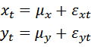
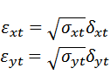
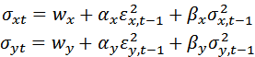
among them,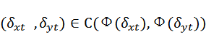, Which conforms to the two-dimensional normal distribution
Known from the form of the mean error of x, y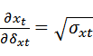 ，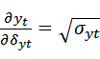 , So the correlation of the Copula function's independent variable sequence is consistent with the correlation of the residual sequence.
Taking the edge distribution of x as an example, the expression can be standardized as:
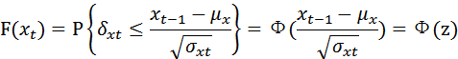
The estimation of Copula and GARCH generally has two methods, MLE and semiparametric. Here we introduce the MLE method. Suppose the estimated parameter set of the GARCH model is θ₁, θ₂, and the estimated parameter set of the Copula function is α, according to Sklar's theorem:
The density function and likelihood function can be derived:
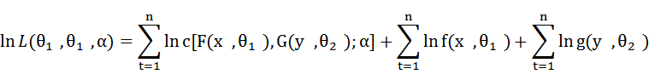
Because there are three parameters in this model that make it difficult to estimate, usually a two-step estimation method is used to estimate the parameters θ₁and θ₂of the GARCH model first, and then estimate the parameter α of Copula.

2.2.5 VaR and CVaR
VaR (value at risk) refers to the maximum possible loss of a financial asset or combination in a specific period under a certain confidence level. VaR is a tool to measure risk, which is different from traditional, β and other tools are intuitive, time-sensitive, have good statistical properties and can measure the advantages of derivatives risk. The Risk Metrics model proposed by J.P. Morgan and the multivariate Copula model used in this case are the most widely used VaR calculation methods. The three important elements of VaR are the confidence level, the holding period and the maximum possible loss. At a given confidence level α and the holding periodThe formula of VaR is expressed as:
CVaR (Conditional Value at Risk) refers to the conditional average value of the maximum loss in a certain period under a certain confidence level. Pure VaR only considers the loss under a given confidence level, and does not consider the loss beyond the confidence interval. CVaR further considers a certain degree of extreme value on this basis. Suppose the loss function of the asset is F(p). Based on the VaR condition, the expression of CVaR is:
VaR has three different measurement methods, which are historical simulation method, MCMC (Monte Carlo) method and Delta-Gamma model analysis method. The historical simulation method uses historical data to predict the current sequence. For example, the simulation distribution of future returns obtained through autoregressive models such as ARMA-GARCH and VAR is the application of historical simulation method. The MCMC method obtains the simulated distribution closest to the real situation by simulating the possible paths of market factor fluctuations. The above two methods use the obtained simulated distribution to calculate the quantile to obtain VaR. The Delta-Gamma model calculates VaR using a linear analytical method, assuming that the asset satisfies a normal distribution, the rate of return is a linear combination of the risk factor delta and its derivative gamma.

3 Ant spends CVaR of ABS

3.1 Sequence descriptive statistics and stationarity test
First, logarithmize the price series of the two assets and perform the first-order difference to obtain the return rate series of the assets, which can make the series more stable while reducing the effects of collinearity and heteroscedasticity. The numerical characteristics of the return series are as follows:
sequence | Sample size | Minimum | Mean | Max | Standard deviation | Skewness | Kurtosis | JB statistics
Priority rate of return | 185 | -0.017267 | 0.000004 | 0.009884 | 0.003004 | -1.620847 | 10.737897 | 539.607904
Mezzanine rate of return | 185 | -0.058269 | -0.000030 | 0.059212 | 0.015145 | 0.213616 | 10.300423 | 410.003392
According to the numerical characteristics of the sequence, in the comparison of the yield of priority securities and mezzanine securities, the minimum and average values ​​of priority are greater than the mezzanine level, and the maximum is less than the mezzanine level. Combined with the principle of ABS realization, the ABS asset pool will be reorganized according to the quality of the underlying assets during the construction process, and the quality of priority assets is higher, so the risk premium of holding the asset is lower, and the absolute value of the performance gain is smaller, but The expected return is higher than the mezzanine level. The standard deviation of the mezzanine level is higher than the priority, which reflects the characteristics of its income is not stable enough. Skewness reflects the distribution of income relative to the mean. Priority and mezzanine skewness are shown as left skewness and right skewness, respectively, and the priority skewness is relatively large, indicating that priority income is relatively more concentrated in the positive income. side. The kurtosis reflects the concentration of income near the mean. The kurtosis level of the two series is higher than 3 of the normal distribution, which reflects the peak and thick tail characteristics of financial data. The JB statistic is used to test whether the variable obeys the normal distribution. The test results show that the hypothesis of normal distribution is significantly rejected. Therefore, the t-distribution form of GARCH is used when establishing the GARCH model.
GARCH-type models usually require variables to be stationary, so ADF stationarity test is performed on the sequence. Use the default regression with only the constant term c and use the AIC criterion to determine the lag order. The test results are as follows:
sequence | t-statistic | p value | Lag order | Number of regression observations
Priority rate of return | -7.241923*** | 1.874632e-10 | 2 | 181
Mezzanine rate of return | -13.34536*** | 5.809500e-25 | 3 | 180
The t-statistics of the ADF test of the two series reject the null hypothesis at the significance level of 1%, and pass the stationarity test. The two series can be regarded as non-trend stationary series with constant terms, and the lag orders are 2 and 3 respectively.

3.2 Serial autocorrelation test and ARCH effect test
To establish a GARCH model, it is necessary to test whether the variable sequence has the ARCH effect.
Firstly, through ACF (autocorrelation) and PACF (partial autocorrelation) diagrams, it is preliminarily judged whether the variables have autocorrelation, and the lag order of ARCH test is selected through observation.
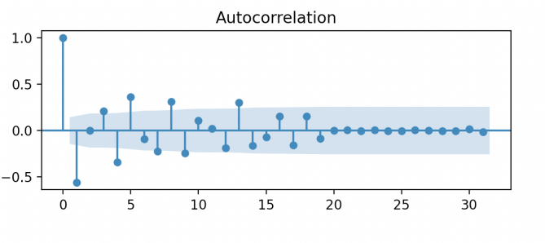
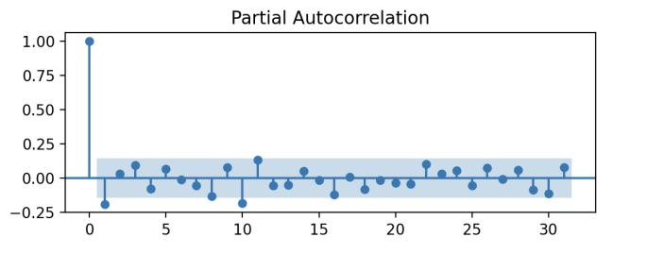
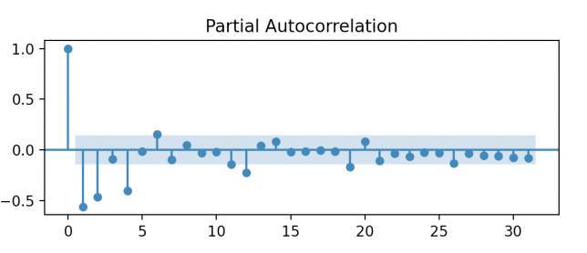
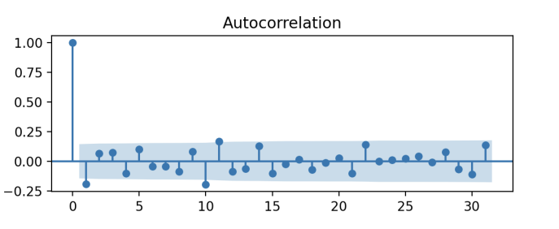
It can be seen from the above four sets of graphs that both variables have a certain degree of autocorrelation. The light blue areas in the two figures above are the confidence boundaries, and the correlation coefficient points all show that the priority sequence basically satisfies the autocorrelation after lagging by 1 order, that is, satisfies the AR(1) and MA(1) processes, so ARCH can be performed later (1) Inspection. In the same way, the possible lag orders in the two figures below are 2 or 4, and ARCH(2) test can be considered.
To judge whether the sequence has the ARCH effect, it should satisfy the heteroscedasticity in addition to the autocorrelation. Ljung-Box Q statistic was used for ARCH effect test. The test results are as follows:
sequence | Ljung-Box Q statistics | p value | Lag order
Priority rate of return | 6.80259745*** | 0.00910254 | 1
Mezzanine rate of return | 58.93159586*** | 1.59649130e-13 | 2
The Ljung-Box Q of the two return rates rejected the null hypothesis at the significance level of 1%, indicating that the sequence has an ARCH effect, which can be estimated using GARCH models.

3.3 AR(1)-GARCH(1,1)-t model estimation and testing
In order to simplify the model complexity and reduce the number of iterations, a GARCH model with a lag order of 1 or 2 is considered. After comparison, the final volatility equation chooses the GARCH(1,1) model, and the average equation chooses the AR(1) model. There are two reasons for the choice. One is that the t-statistics of the parameters are more significant and the statistical properties are better; the second is that the higher the lag order, the more parameters that need to be estimated, and the more complicated the final yield equation is, which is not conducive to the progress. After the Copula function estimation and VaR calculation. The parameter estimation results are as follows:
Priority asset-backed securities yield
variable | parameter | Standard deviation | t-statistic | p value | equation
Omega | 0.00064861 | 0.00003847 | 16.860 | 0.000 | Standard deviation equation
Alpha[1] | 0.9993 | 0.552 | 1.809 | 0.070
Beta[1] | 0.00031982 | 0.000105 | 3.0470 | 0.002
Const | 0.00018171 | 0.0001.570 | 1.158 | 0.247 | Mean equation
Mezzanine-level asset-backed securities yield
variable | parameter | Standard deviation | t-statistic | p value | equation
Omega | 5.6419e-06 | 2.472e-06 | 2.282 | 0.018 | Standard deviation equation
Alpha[1] | 0.9997 | 1.006 | 0.994 | 0.320
Beta[1] | 0.00026174 | 0.0000 1162 | 2.253 | 0.000
Const | 0.00025396 | 0.0000141 | 18.043 | 0.000 | Mean equation
The alpha and beta in the standard deviation equation are the ARCH and GARCH coefficients of the model, respectively. The GARCH model is valid only when the sum of the two terms is less than 1. The results show that the two series meet this condition and are very close to 1. It shows that conditional variance plays an important role in the model. After organizing the two sets of equations, we can get:
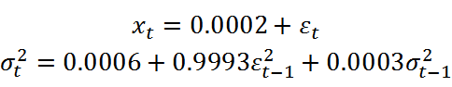
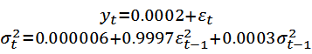
The AR(1)-GARCH(1,1) model of the rate of return can be obtained. The test of the model can again use the Ljung-Box Q statistic to test the ARCH effect of the residual of the mean equation. If the residual does not have the ARCH effect, it can be proved that the GARCH model has fully described the autoregressive heteroscedasticity of the sequence. It proves that the model is effective. In addition, the Copula function needs to be estimated for the two marginal distributions. Therefore, the distribution function of the model, that is, cdf, as a variable, should also be tested whether it satisfies the uniform distribution of U[0,1]. The test method uses K-S statistics. The results of the two inspections are as follows:
sequence | Ljung-Box Q statistics | p value (Ljung-Box Q statistic) | K-S statistics
Priority rate of return | 0.00061656 | 0.98018999 | 0.0491
Mezzanine rate of return | 0.10928912 | 0.74095492 | 0.0491
The results show that the residuals no longer have the ARCH effect at this time, and the original hypothesis that the edge distribution conforms to the uniform score is not rejected. The model can be used for subsequent correlation estimation and prediction of the sequence.

3.3 Copula function estimation and test
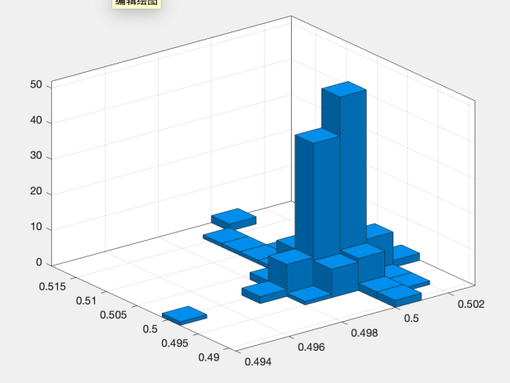
Copula function has many forms, so if you want to estimate, you must first choose a certain function form. Observe the distribution characteristics intuitively by drawing a binary histogram of two variables as follows.
The characteristic of the binary histogram is that the two edge distributions are relatively concentrated, and although the distribution state has a slightly left-skewed nature, it is generally similar to a non-skew distribution such as a normal distribution or a t-distribution. Therefore, considering choosing one of the two functions Gaussian Copula and t-Copula in the elliptic Copula function cluster as the model, it can be clearly seen that the edge distribution has the characteristics of sharp peaks and thick tails, so t-Copula is relatively more reasonable. The parameter estimation results of t-Copula are:
function | Linear correlation parameter matrix | Degree of freedom parameter
t-Copula |  | 1
To test the model, a random sample with a capacity of 1000 is randomly generated from the estimated t-Copular function and drawn into a two-dimensional scatter plot:
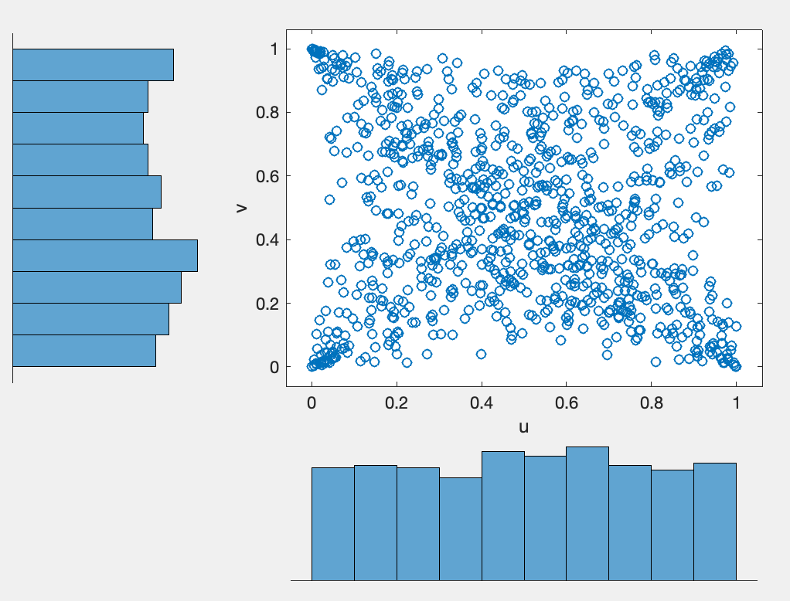
From the scatter plot, the two marginal distribution sequences basically satisfy the uniform distribution, which shows that the estimation results of the model itself are not problematic.

3.4 VaR, CVaR calculation
According to the weight parameter value estimated by the Copula function, the priority and mezzanine-level assets are processed again to generate a portfolio return rate sequence. This sequence is a combination of market risk assets and credit risk assets, and can also be regarded as a combination of overall risk. Because the Copula function here is based on the estimated value under the condition of the hypothetical function form, it is not suitable for calculating VaR as an expression in the analytical method, so it is decided to simulate VaR with the MCMC method. The MCMC algorithm uses random numbers that obey the standard normal distribution. The number of iterations is not too high due to insufficient sample size. The number of simulations is 1000, and the number of steps for a single simulation is 10. The calculated result is VaR at the 95% significant level. According to VaR, the average value of the loss value higher than VaR is CVaR.
sequence | Where | CVaR
Copula-GARCH portfolio return series | -0.130 | -0.157
The result of CVaR is significantly higher than the average profit and loss level of the financial industry, which shows that the research object has shown certain risk problems.

3.5 Defects and deficiencies of CVaR solution process
Due to the great deficiencies in personal research level and tools, the final results are for reference only, and there is a big deviation from the actual level. The following describes some of the problems in this section.
The primary problem is that the selected data itself is not a real time series, but discrete data in the entire time period, and the law of the price announcement date is difficult to find, and it is extremely difficult to restore the time series data. Therefore, the use of time series models to simulate data actually has a lot of defects, and the results of simple ARMA-GARCH models have little meaning for the interpretation of the problem.
Secondly, because of the first contact with this aspect, the understanding of the model is insufficient and there may even be fallacies, and the testing methods required for the model are not familiar enough. The tools for model construction and verification in this section are the Python 3.9 interpreter and various statistics-related python third-party libraries such as MatlabR2017b. Python third-party library standards are different, and the development quality is uneven, resulting in a lack of content in the final result. For example, Copula and VaR did not find a suitable parameter verification method, and only adopted a method similar to image analysis to roughly test the model. .
Finally, it is stated that although there are various problems in the construction of the model, the process is relatively complete, and the CVaR value simulated by the MCMC method is relatively high, which is worthy of causing the problem of this case study-the ABS risk problem of ants. Explore.

4 Comprehensive analysis of ABS risk of Ant Group
The listing of Ant Group was suspended. There are countless possibilities of problems in the eyes of the regulatory authorities, but all of them may cause two results. One is that the Ant Group has systemic risks, which will affect all walks of life after exposure. , Causing significant social property losses; second, ants' own business model has non-systematic risks, and may enter property dilemmas when operating poorly, causing losses to investors.
As the most important part of the risk factors of Ant Group, ABS risk can also be analyzed from the same perspective. The main participants of ABS are basic asset holders, spv and securities investors. Among them, the basic asset holders and securities holders correspond to the formation and assumption of the Ant Group's risks, and also correspond to the Ant Group's unsystematic and systemic risks; while the spv, as an intermediary institution, generally only serves as risk transmission. And a certain control function, and ABS is a special asset that issues securities based on the cash flow of the underlying assets. It is difficult for the spv to complete the function of optimal asset portfolio allocation, which further weakens its risk management ability, so no special analysis is made for the spv , Its own risks are also spread between the other two parties. Let's analyze some key risk issues one by one.

4.1 Risks for holders of underlying assets
ABS is essentially a risk transfer asset. After the underlying asset is sold by the holder to the spv, the holder receives cash, and the cash flow generated by the asset is paid as a reward. Therefore, for this party, ABS is essentially similar to fixed The swap of assets and floating assets plays a role in fixing income. In terms of risk-taking, the holders of basic assets are obviously the party who gains, and the risks they bear are mainly reflected in liquidity risk, interest rate risk, credit rating risk and policy risk.

4.1.1 Liquidity risk
As an asset provider, although the ownership of the asset has been transferred, it is still above the entire ABS capital flow chain. If there is a problem with liquidity, it may cause the capital turnover to become unavailable and cause investors to suffer losses. On the other hand, losses do not only occur among investors. If liquidity risks lead to lower asset quality, it will indirectly lead to lower ABS prices. Therefore, the holders of basic assets will still bear their own liquidity risks.
Investigating the liquidity risk of Ant Group can be based on financial indicators such as current ratio and asset-liability ratio. The following two figures are the balance sheet and cash flow statement of Ant Group in the past three years.
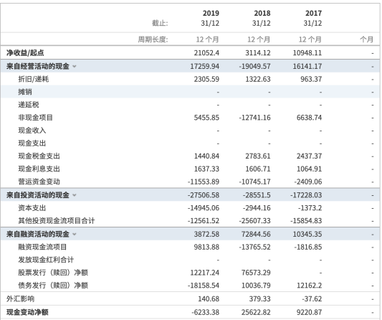
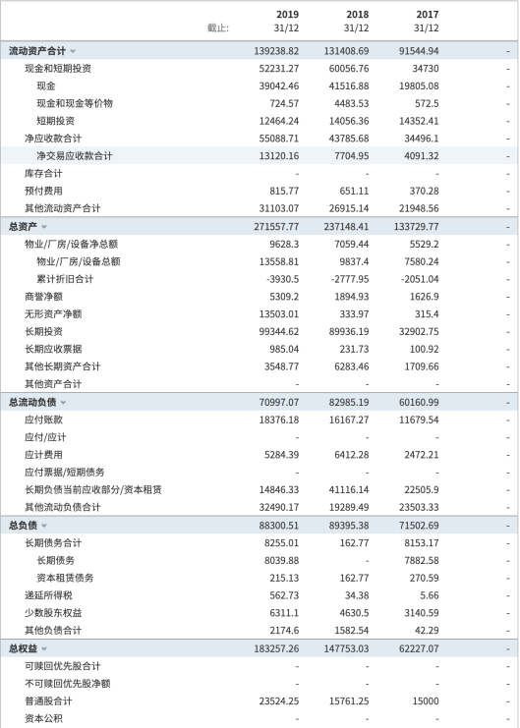

In the past three years, only the current ratio in 2019 was less than 1, but it was similar to 1. At the same time, a large decrease in long-term liabilities from 17-18 was observed. Therefore, it is speculated that the decrease in current ratio may be related to the repayment of long-term liabilities. The debt-to-asset ratio is increasing year by year, which shows that the solvency of enterprises is actually in a process of gradual increase. The cash flow on the right also confirms this point. The cash inflow in 17-18 was positive and negative in 19, and the main outflow was concentrated in investment activities and debt redemption. On the whole, the liquidity risk of Ant Group is not obvious.

4.1.2 Interest rate risk
Interest rates are the opposite of security prices. Basic asset holders need to pay cash flow in the form of interest when selling ABS. Therefore, interest rate is a cost to this party, and any factor that may cause interest rate changes constitutes interest rate risk.
In terms of risk types, interest rate risk is a part of market risk. There are three basic interest rate risk factors, namely the default risk of securities, liquidity and taxation, which is also called the risk structure of interest rates. The default risk of securities is closely related to the liquidity risk of asset holders. The latter is a factor that constitutes the former; the liquidity of securities is a market factor, which depends more on the maturity and the overall preferences of investors; the taxation of securities is relatively independent , And usually not as the main factor.
From the CVaR value and Copula function weight parameters in Section 3, the market risk of the ant group is very large. As an important part of it, interest rate risk is also closely related to other risks.

4.1.3 Credit rating risk
The evaluation of the price and interest rate of securities is usually based on the credit rating, and the classification of the credit rating depends on the nature of the assets, market trends and credit enhancement methods. Credit rating risk is related to liquidity risk and interest rate risk.
According to the sample statistics of 1093 Ant ABS securities searched in CNABS, there are a total of 372 priority levels and a total of 353 mezzanine levels. It is not reasonable in terms of proportions. A large number of low-quality assets lack the protection of high-quality assets. But on the other hand, the corresponding relationship between my country's current ABS rating and credit rating is: AAA-priority, AA+-mezzanine level, NR-subordinate, even relatively low-quality asset ratings are higher . In general, the credit rating risk is not obvious, because the vast majority of ABS securities are above the AA+ level.
It is worth mentioning that obtaining higher ratings for low-quality assets is not a good signal. In 2008, the United States was a precedent. At that time, more than 75% of U.S. ABS securities were rated above AAA, and this also became a trigger. A major cause of the subprime mortgage crisis.

4.1.4 Policy risk
Policy risk refers to the risk of unexpected gains and losses due to policy influences. The policy covers both the macro fiscal and monetary policy, as well as the micro laws and regulations promulgated for a certain industry. According to general research results, the correlation between policy risks and other types of risks is relatively small.
For policy risks, this case is an example of significant unexpected losses caused by policy risks. So far, from the perspective of the entire Internet finance industry, major companies have relatively high policy risks.
翻.1
译.2
狗.3
/
翻.4
译.5
狗.6
/
翻.7
译.8
狗.9
/
翻.10
译.11
狗.12
/
翻.13
译.14
狗.15
/
翻.16
译.17
狗.18
/
翻.19
译.20
狗.21
/
翻.22
译.23
狗.24
/
翻.25
译.26
狗.27
/
翻.28
译.29
狗.30
/
翻.31
译.32
狗.33
/
翻.34
译.35
狗.36
/
翻.37
译.38
狗.39
/
翻.40
译.41
狗.42
/
翻.43
译.44
狗.45
/
翻.46
译.47
狗.48
/
翻.49
译.50
狗.51
/
翻.52
译.53
狗.54
/
翻.55
译.56
狗.57
/

4.2 Risks of securities investors
As mentioned before, securities investors are at a disadvantage in the transactions between holders of underlying assets. The reason is that holders of underlying assets transfer the risks of their original assets to investors, making investors bear the risks of ABS securities. At the same time, it also needs to bear the risk of its underlying asset cash flow. On this basis, the following will analyze the credit risk, cash flow risk and circulating pool risk assumed by investors.

4.2.1 Credit risk
Credit risk usually refers to the default risk that the creditor of the asset suffers from the debtor. The reasons for default are various, mostly due to liquidity or market factors. Credit risk is of great significance for such credit-intensive enterprises operating deposit and loan business. It can be said that credit is the cornerstone of finance.
In Section 3, it is not accurate to use the mezzanine security yield as a variable of credit risk assets. In fact, the main risks contained in this type of security include both credit risk and market risk, but this is when the Copula function is used to form a joint distribution. Can be eliminated. Although the weight is not as large as the market risk, the proportion of credit risk in CVaR is still not small, and it needs to be regarded as the main risk factor. In addition, in the statistical description, the mezzanine level is opposite to the priority and has a right-biased nature, indicating that the return rate is distributed below 0. There are more loss areas. This shows that the negative impact of credit risk on the return rate is greater, and even makes the mezzanine level expectation The revenue is lower than the priority.
Credit risk also contains a special risk principle-moral hazard. Since the relationship between the investor and the asset holder has already occurred after the transaction, and the latter does not bear complete losses and is not fully supervised by the contract holder, this causes the latter to maintain inconsistency to a certain extent, and even Disobey the agreement at all.

4.2.2 Cash flow risk
1.翻
2.译
3.狗
/
4.翻
5.译
6.狗
/
7.翻
8.译
9.狗
/
10.翻
11.译
12.狗
/
13.翻
14.译
15.狗
/
16.翻
17.译
18.狗
/
19.翻
20.译
21.狗
/
22.翻
23.译
24.狗
/
25.翻
26.译
27.狗
/
28.翻
29.译
30.狗
/
31.翻
32.译
33.狗
/
34.翻
35.译
36.狗
/
37.翻
38.译
39.狗
/
40.翻
41.译
42.狗
/
43.翻
44.译
45.狗
/
46.翻
47.译
48.狗
/
49.翻
50.译
51.狗
/
52.翻
53.译
54.狗
/
55.翻
56.译
57.狗
/
Since the interest rate of ABS securities is consistent with the cash flow generated by the underlying assets, the fluctuation of cash flow will also directly affect ABS securities, which constitutes a cash flow risk. This part of the risk comes from the original holder of the underlying asset, which is the part of the risk transferred by the holder of the underlying asset. Same as the liquidity risk in the previous section, the cash flow risk will also break the capital chain and cause investors' losses.
For investors, this problem is also divided into different situations of priority, mezzanine, and secondary. Similar to the priority residual claim relationship of debt and equity, ABS securities are also tiered under the condition of certain cash flow. Therefore, priority securities are better than mezzanine for investors at this point.

4.2.3 Risk of circulating pool
The circulating pool is a special transaction structure opposite to the static pool. The static pool is the general form of ABS. Spv buys all assets at once, and the assets in the asset pool remain fixed. The circulating pool is that the cash flow generated by the basic assets is not completely used for distribution to investors, but is used to continuously purchase new basic assets, so that the basic asset pool forms a dynamic circulating pool.
Take Ant Borrow as an example, the basic assets of Ant Borrow are micro loans provided to the majority of users. Under the conditions of the revolving pool, when some users repay the cash flow generated by a small loan, the money may not be used to pay the interest of borrowing ABS securities immediately, but will be transferred to other users to provide other users. A loan. In this way, a mechanism similar to commercial bank credit expansion is formed. Theoretically, the asset pool can be expanded indefinitely. At the same time, it is also a process in which risks can accumulate infinitely.
Among a total of 379 Ant ABS products included in CNABS, 211 asset pools belong to the form of circulating pools. Although the circulating pool has the advantages of improving liquidity and solving the problem of maturity mismatch, it will also further increase the risk of ABS at the same time.

4.3 Other risks
1.翻
2.译
3.狗
/
4.翻
5.译
6.狗
/
7.翻
8.译
9.狗
/
10.翻
11.译
12.狗
/
13.翻
14.译
15.狗
/
16.翻
17.译
18.狗
/
19.翻
20.译
21.狗
/
22.翻
23.译
24.狗
/
25.翻
26.译
27.狗
/
28.翻
29.译
30.狗
/
31.翻
32.译
33.狗
/
34.翻
35.译
36.狗
/
37.翻
38.译
39.狗
/
40.翻
41.译
42.狗
/
43.翻
44.译
45.狗
/
46.翻
47.译
48.狗
/
49.翻
50.译
51.狗
/
52.翻
53.译
54.狗
/
55.翻
56.译
57.狗
/
In addition to the risks listed above, there are some other types of risks, such as:
The liquidity risk, credit risk, market risk, etc. of the original holder of the underlying assets will be passed down, forming a common risk on the entire West Capital Chain;
The early payment and early redemption of securities will cause greater pressure on liquid assets, resulting in liquidity and credit risks.
The agency cost of related participating institutions, additional agency risks and so on.

4.4 ABS risk summary
Through the above analysis, it can be found that the ABS risk of Ant Group has several characteristics:
- Risk is transitive from top to bottom:
In the entire issuance process of ABS, it is actually accompanied by a risk transfer process. First, the original users who provided the basic assets to the Ant Group passed their own risks to the Ant Group at the cost of paying cash flow, and then Ant sold ABS for risk isolation, and the risk continued to be passed on to the majority of investors.
- The risks between the underlying asset investor and the investor are symmetric:
In fact, the relationship between the risks assumed by the Ant Group and investors is basically a coin with two sides. The liquidity risk and interest rate risk of Ant Group are actually their credit risk for investors.

3. The higher the credit risk, the lower the efficiency of securities
Take the mezzanine securities that bear more credit risk as an example. The expected return of this type of securities is low, and the lower repayment sequence leads to higher liquidity risk.
- Industry faces policy risks
At present, the development of my country's ABS is far from reaching a mature stage, and various mechanisms have certain defects. It is the time for reform and policy support. The incident of the Ant Group is probably just the beginning.
1.翻
2.译
3.狗
/
4.翻
5.译
6.狗
/
7.翻
8.译
9.狗
/
10.翻
11.译
12.狗
/
13.翻
14.译
15.狗
/
16.翻
17.译
18.狗
/
19.翻
20.译
21.狗
/
22.翻
23.译
24.狗
/
25.翻
26.译
27.狗
/
28.翻
29.译
30.狗
/
31.翻
32.译
33.狗
/
34.翻
35.译
36.狗
/
37.翻
38.译
39.狗
/
40.翻
41.译
42.狗
/
43.翻
44.译
45.狗
/
46.翻
47.译
48.狗
/
49.翻
50.译
51.狗
/
52.翻
53.译
54.狗
/
55.翻
56.译
57.狗
/
翻.1
译.2
狗.3
/
翻.4
译.5
狗.6
/
翻.7
译.8
狗.9
/
翻.10
译.11
狗.12
/
翻.13
译.14
狗.15
/
翻.16
译.17
狗.18
/
翻.19
译.20
狗.21
/
翻.22
译.23
狗.24
/
翻.25
译.26
狗.27
/
翻.28
译.29
狗.30
/
翻.31
译.32
狗.33
/
翻.34
译.35
狗.36
/
翻.37
译.38
狗.39
/
翻.40
译.41
狗.42
/
翻.43
译.44
狗.45
/
翻.46
译.47
狗.48
/
翻.49
译.50
狗.51
/
翻.52
译.53
狗.54
/
翻.55
译.56
狗.57
/

5 Countermeasure analysis
To a large extent, the risk problem of Ant Group ABS has been able to represent the most prominent part of the corporate risk problem. Not only the Ant Group, but similar companies in the industry, such as JD Digital, Suning Digital and other companies, are all typical of the industry: using ABS to continuously issue additional capital to obtain huge amounts of financing, thereby driving the development of other sectors. Therefore, solving the ABS risk is the magic weapon to truly realize industry reform and healthy and sustainable development.
According to the conclusion of Section 4, the key to solving ABS risk is credit risk from the perspective of the enterprise, and actively reform and pave the way from the perspective of the regulatory agency.

5.1 Countermeasure 1: Improve industry rules and regulations
For the Internet financial industry, new technologies and things are emerging in an endless stream, and it is difficult for supervision to keep up with the pace of innovation. Therefore, careful regulations must be set up to contain all risk factors in the cradle. It can be considered to learn from the mature supervision model and risk control technology of the traditional financial industry, and to innovate according to the characteristics of the industry to create a set of the most suitable institutional system. Important risk variables such as leverage ratio need to be frequently observed and controlled. If things go on like this, my country's mutual gold industry will surely show a new look.

5.2 Countermeasure 2: Strengthen the credit investigation system
The best way to solve the problem of credit risk is to eliminate the phenomenon of breach of trust and default from the root cause. Assuming that our country's credit information system is sufficiently developed, we can ensure that everyone maintains absolute compliance on credit issues, and once we find that there is dishonesty, we can stop it in a very short time. If necessary, it can also be considered to be combined with AI, blockchain and other technologies, using machines to automatically identify users' untrustworthy intentions and distributed databases to quickly transmit data.
1.翻
2.译
3.狗
/
4.翻
5.译
6.狗
/
7.翻
8.译
9.狗
/
10.翻
11.译
12.狗
/
13.翻
14.译
15.狗
/
16.翻
17.译
18.狗
/
19.翻
20.译
21.狗
/
22.翻
23.译
24.狗
/
25.翻
26.译
27.狗
/
28.翻
29.译
30.狗
/
31.翻
32.译
33.狗
/
34.翻
35.译
36.狗
/
37.翻
38.译
39.狗
/
40.翻
41.译
42.狗
/
43.翻
44.译
45.狗
/
46.翻
47.译
48.狗
/
49.翻
50.译
51.狗
/
52.翻
53.译
54.狗
/
55.翻
56.译
57.狗
/
翻.1
译.2
狗.3
/
翻.4
译.5
狗.6
/
翻.7
译.8
狗.9
/
翻.10
译.11
狗.12
/
翻.13
译.14
狗.15
/
翻.16
译.17
狗.18
/
翻.19
译.20
狗.21
/
翻.22
译.23
狗.24
/
翻.25
译.26
狗.27
/
翻.28
译.29
狗.30
/
翻.31
译.32
狗.33
/
翻.34
译.35
狗.36
/
翻.37
译.38
狗.39
/
翻.40
译.41
狗.42
/
翻.43
译.44
狗.45
/
翻.46
译.47
狗.48
/
翻.49
译.50
狗.51
/
翻.52
译.53
狗.54
/
翻.55
译.56
狗.57
/

5.3 Countermeasure 3: Enterprises strengthen investment in technology research and development
The biggest advantage of the Internet financial industry over the traditional financial industry is that it occupies the highest quality platform of the Internet. The development of Internet-related fields is the general trend, and almost all information resources and viewpoint output are concentrated here. If the mutual gold industry can make full use of this advantage, all existing problems will be solved. Technology is the primary productive force. If an enterprise abandons purely pursuing risks and returns and instead focuses on technology research and development, I believe that the industry will certainly achieve substantial development.

